Project Unit

P1

Contributers Page on Github

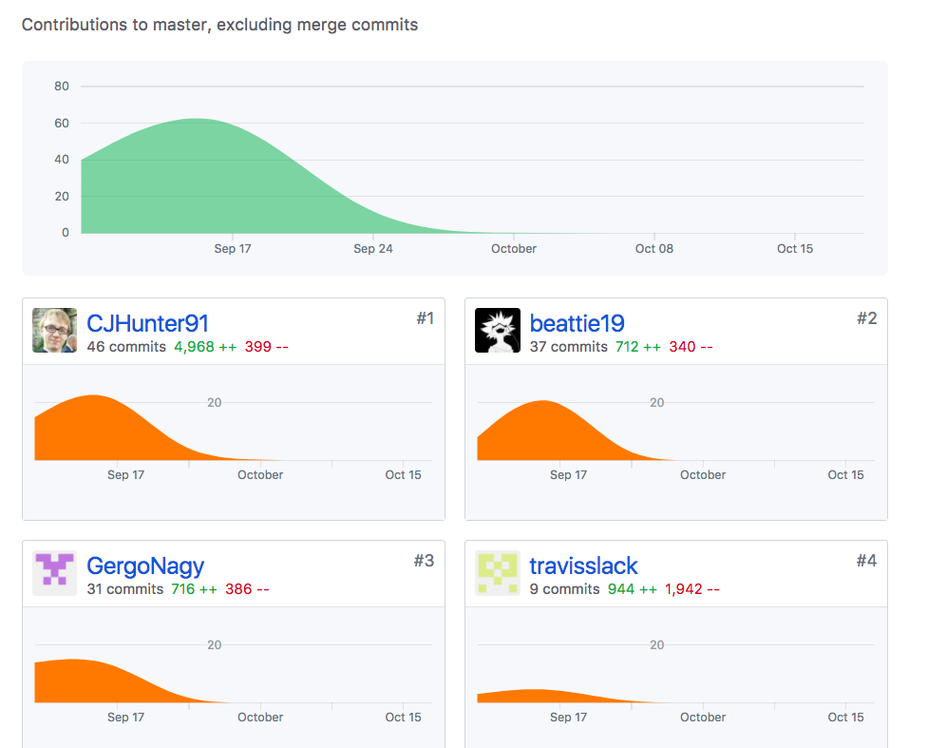

P2

Screenshot of the Project Brief

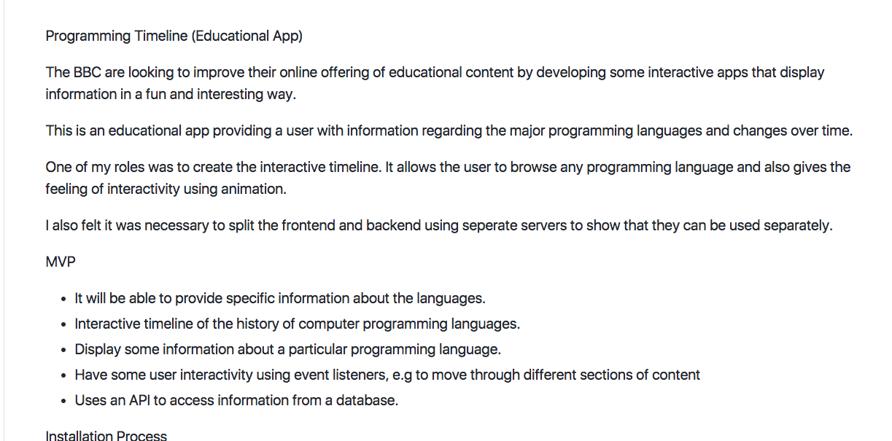

P3

Screenshot of the planning we completed on group project

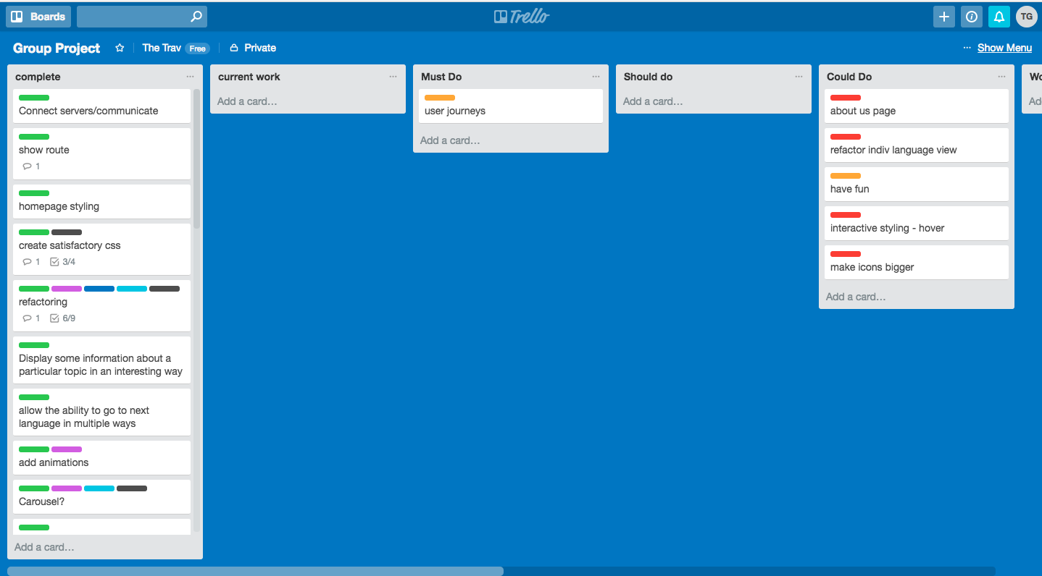

P4

Acceptance Criteria and test plan

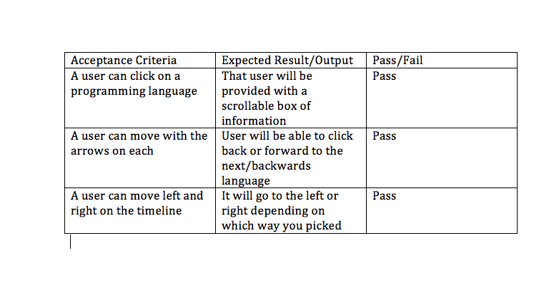

P5

A user sitemap

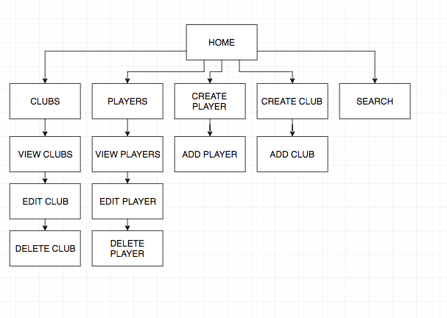

P6

Two Wireframes

Wireframe 1

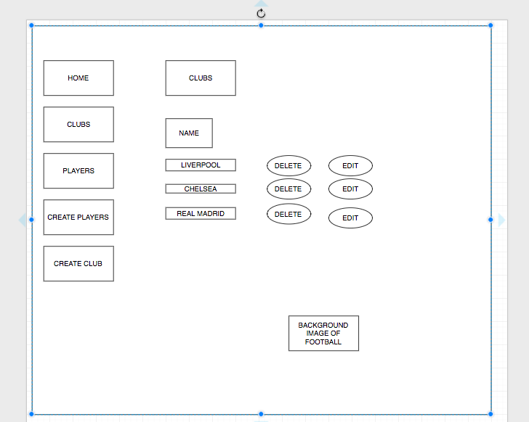

Wireframe 2

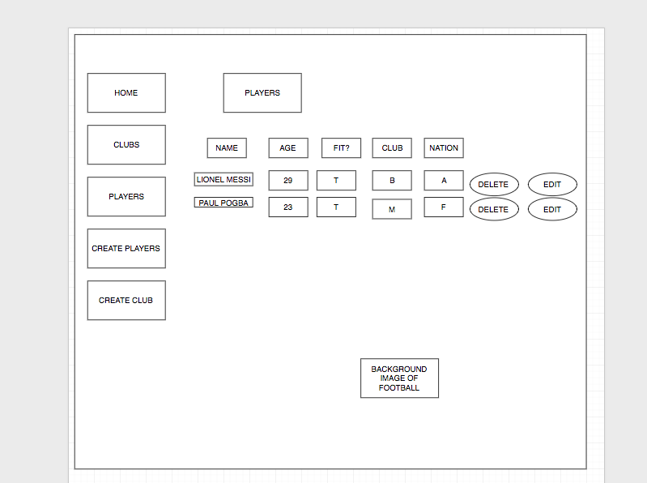

P7

Two system Interaction Diagrams

First diagram

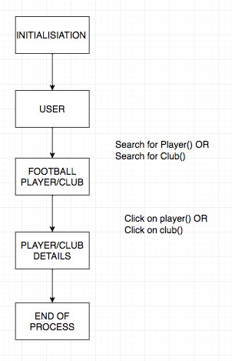

Second Diagram

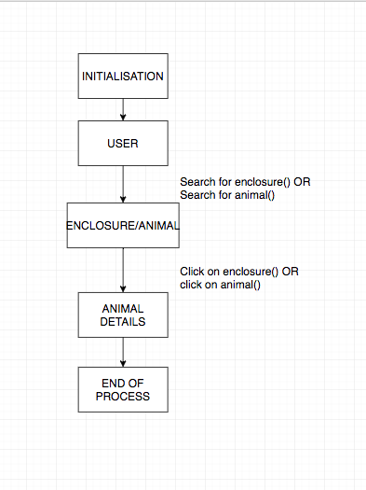

P8

Two Object Diagrams

First Object Diagram

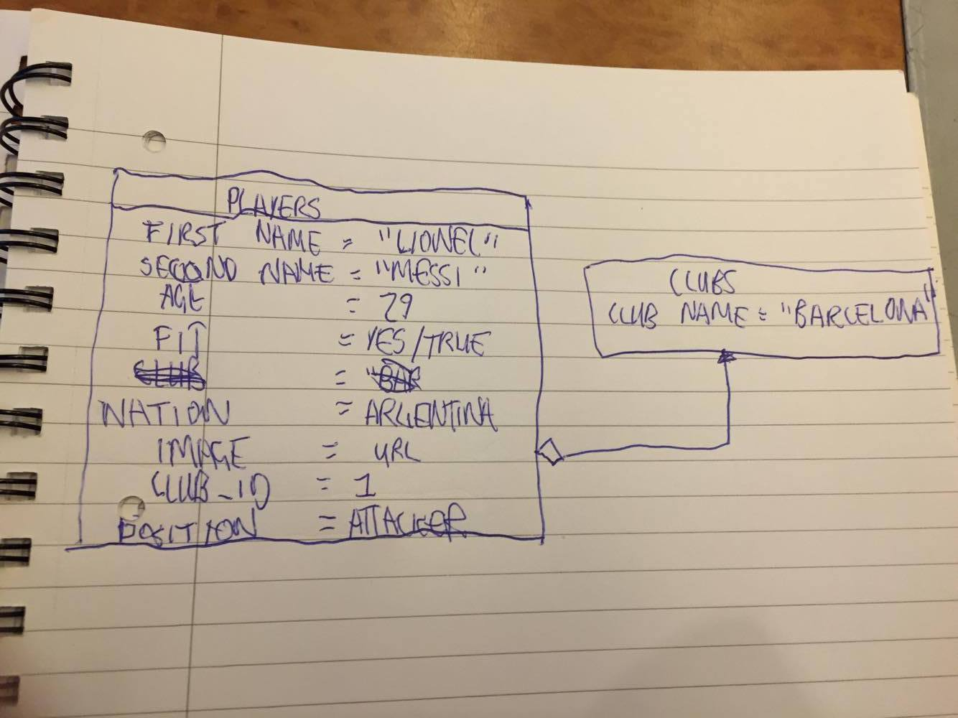

Second Object Diagram

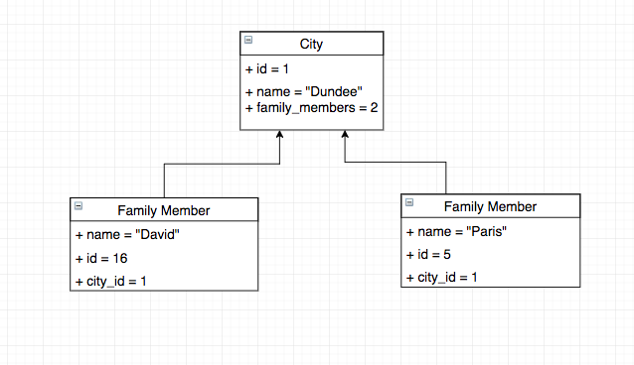

P9

Two algorithms

The first algorithm is looping through the array list of enclosures and finding if there is any space by checking the animalCount() to the size of the enclosure

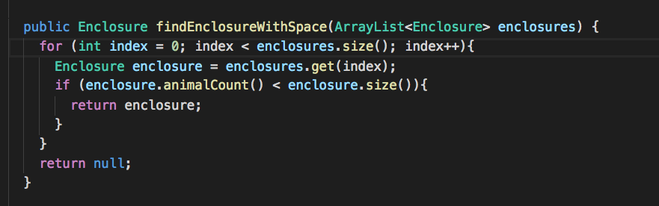

The second algorithm will then house the available animal in the right enclosure if it is the right animal to enclosure

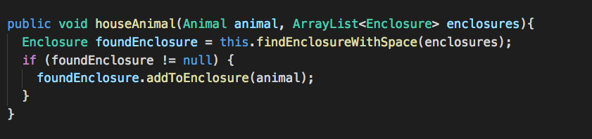

P10

Example of pseudocode

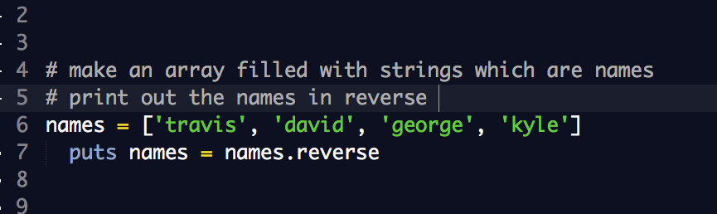

P11

Project where I’ve worked alone and link to github

The Github link:

<https://github.com/travisslack/Games-Console-Timeline>

The Screenshot

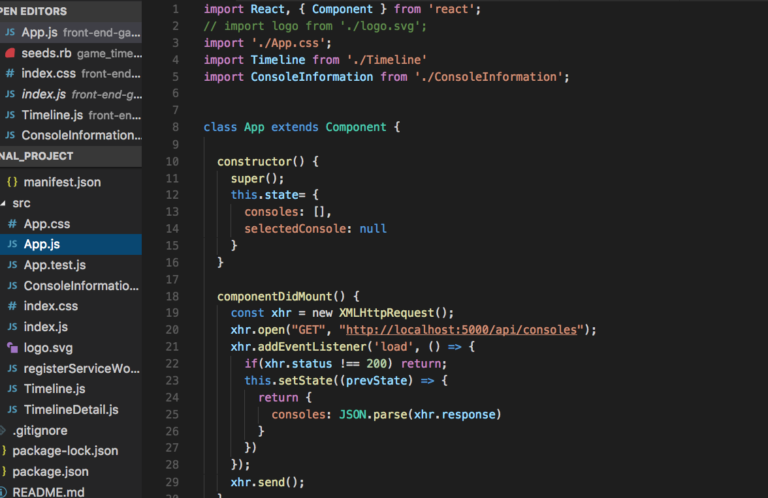

P12

Screenshot of planning or different development stage

Class Diagram from first Ruby Project

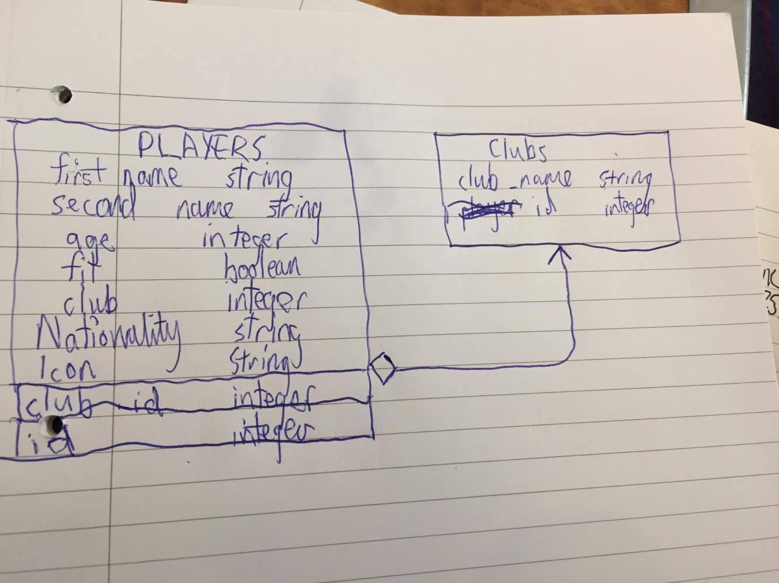

Trello board from first project too

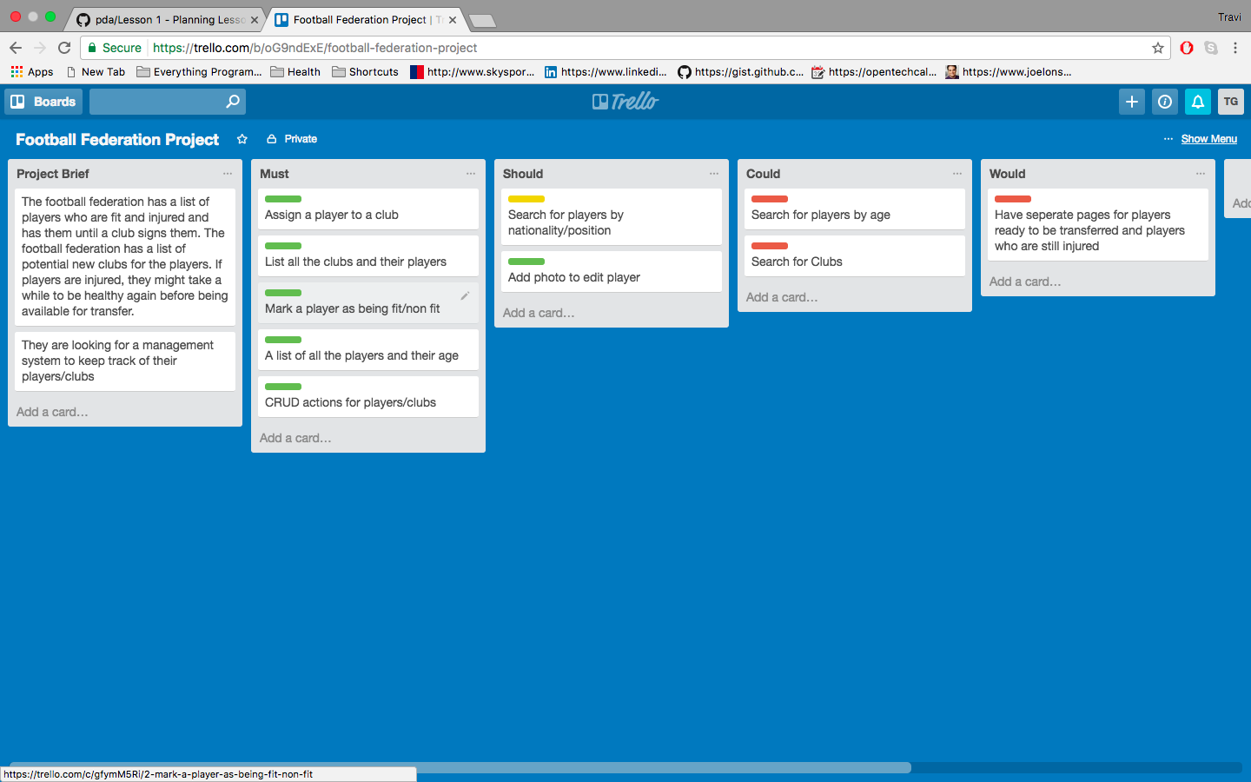

P13

User input being put in and also show it being saved

User inputting something to the program

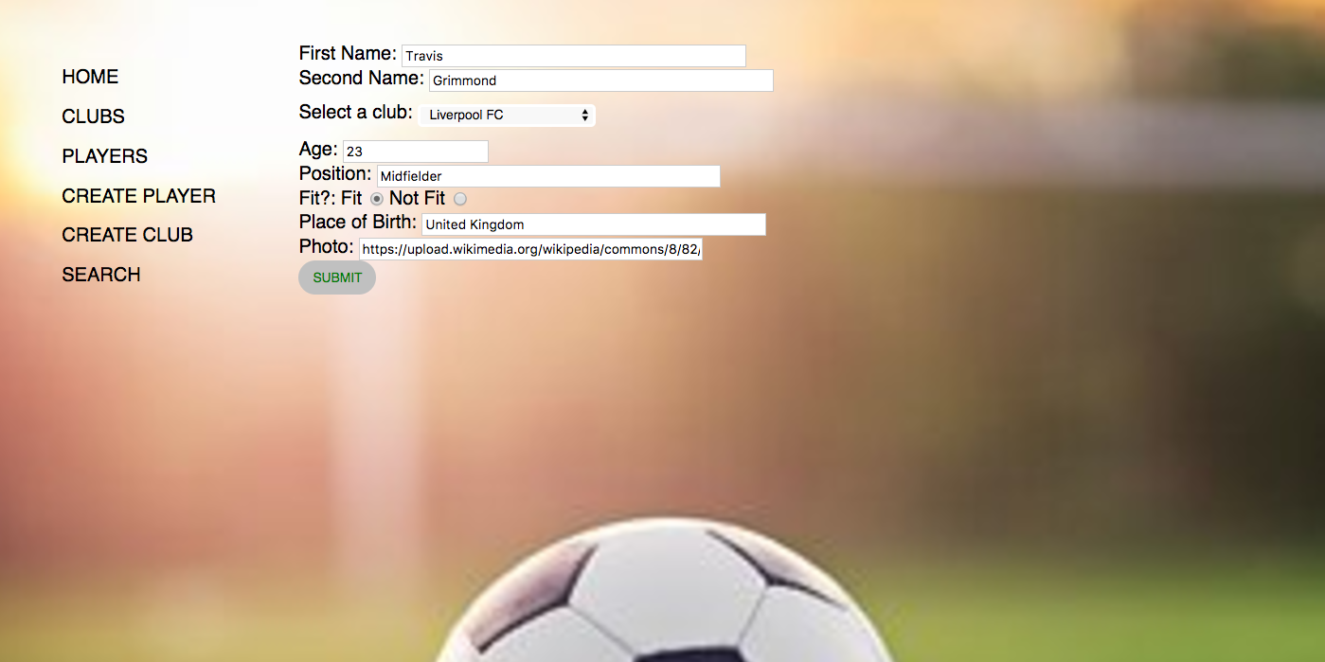

User input being saved

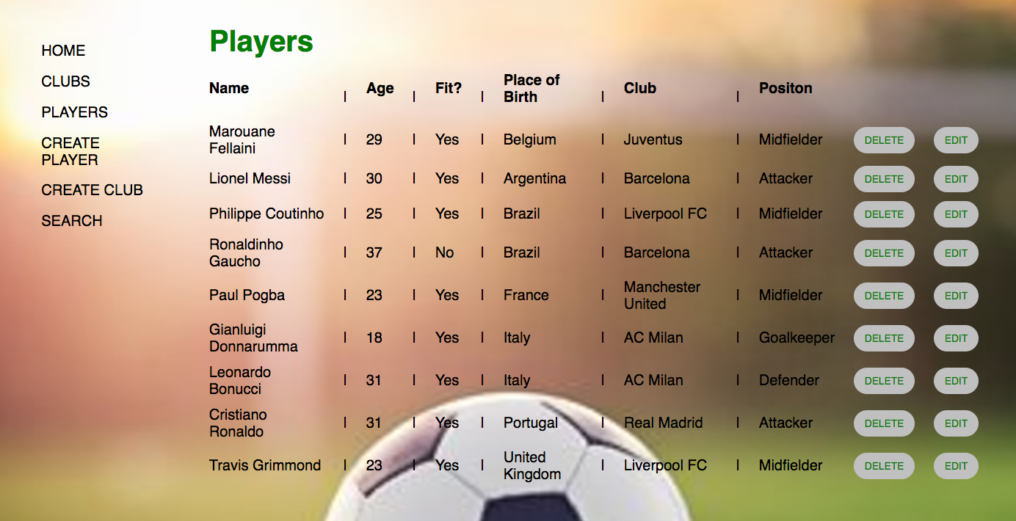

P14

Interaction with Data Persistance

The program before data was put into it

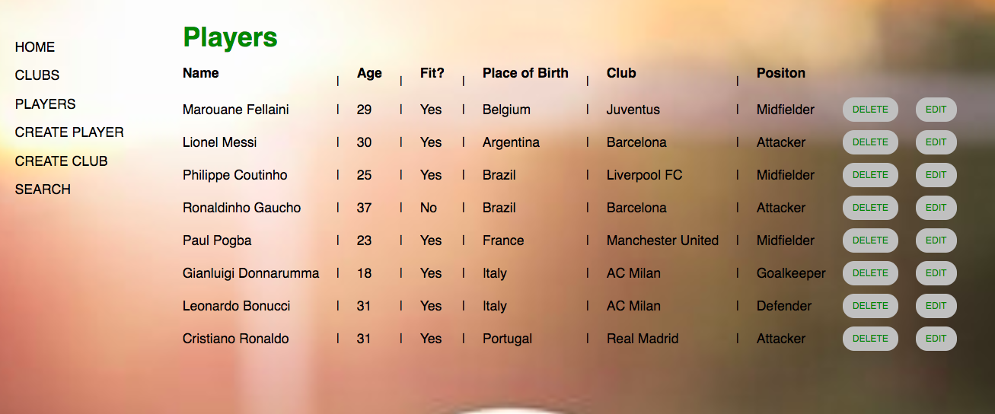

Data being put into the program

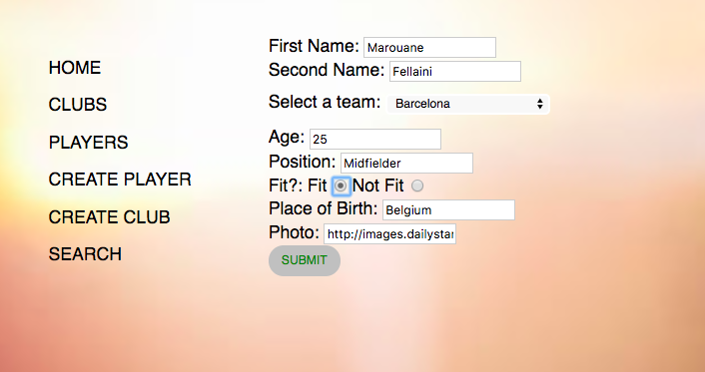

What the data now looks like

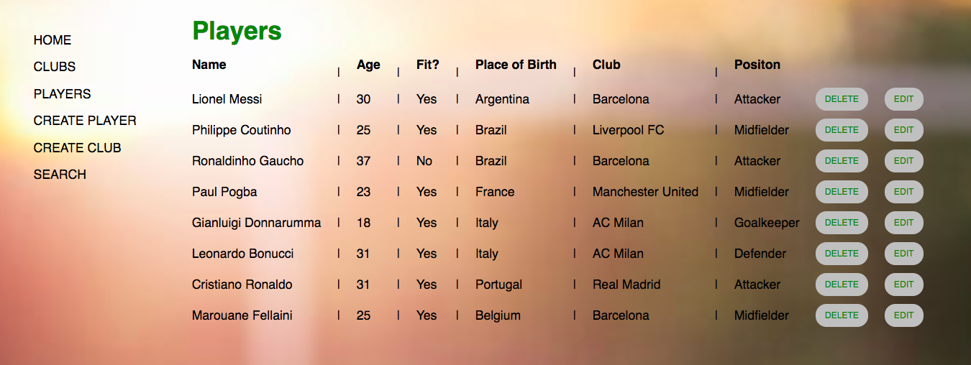

P15

Show the correct output of results and feedback to the user

user requesting information or an action to be performed

The user requested for the bottom ‘player’ to be deleted with the delete button

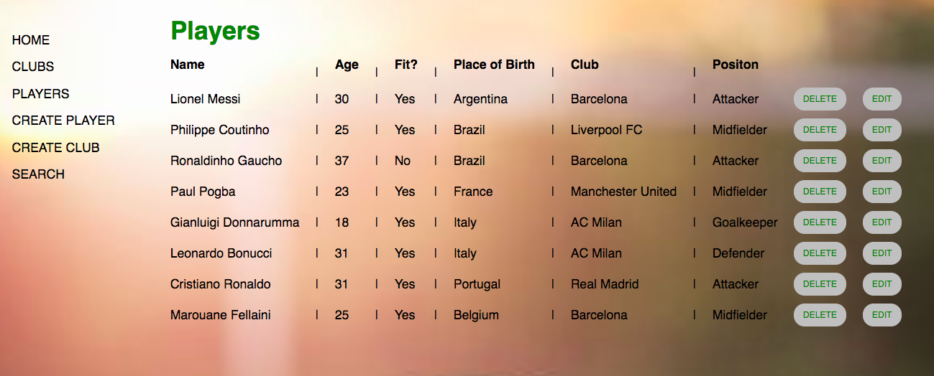

The user request being processed correctly and demonstrated in a program

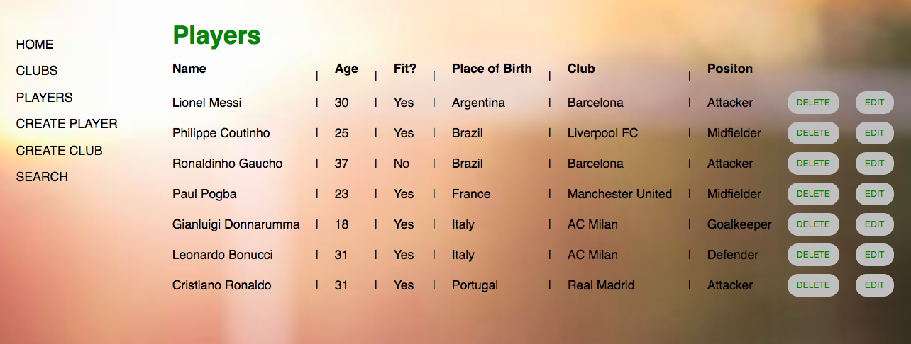

P16

Show an API being used within the program

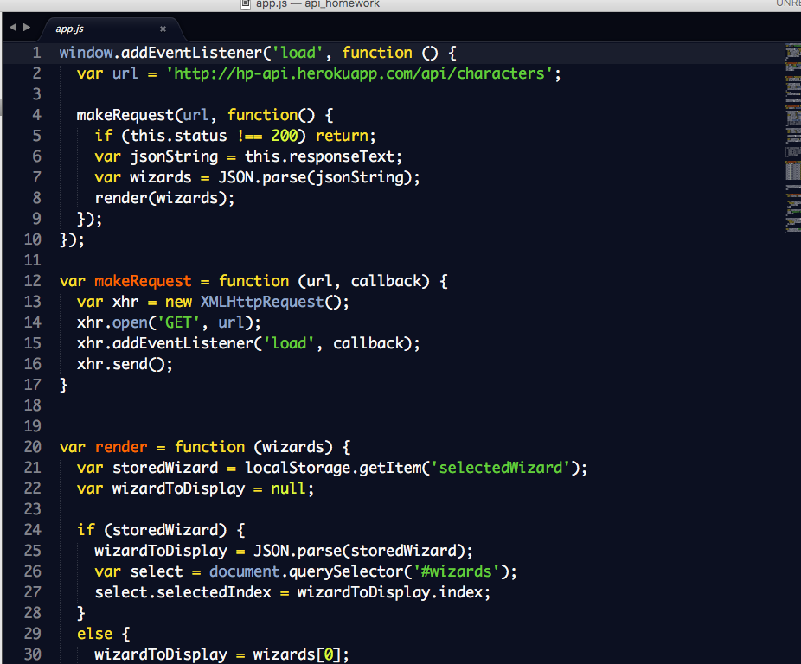

P17

Produce a Bug Tracking Report

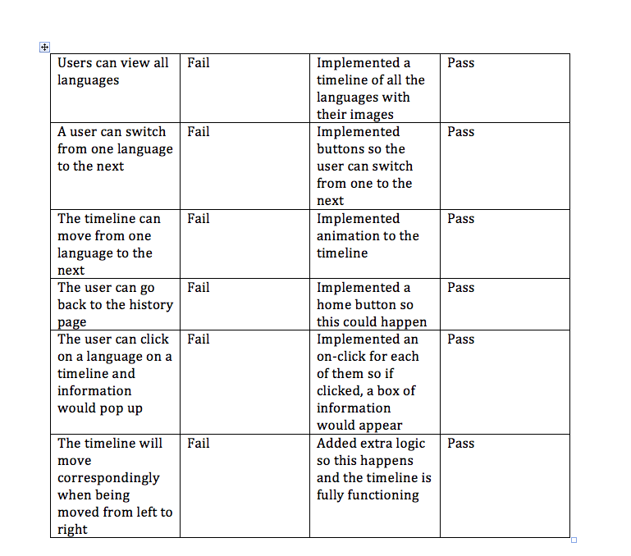

P18

Demonstrate Testing in the program

Example of Test Code –

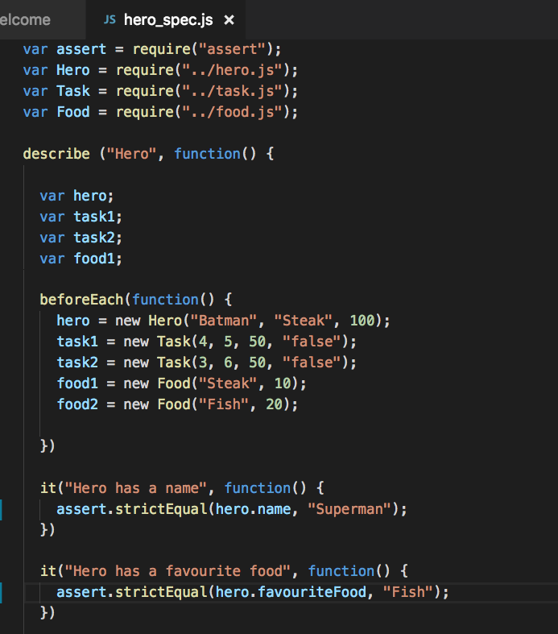

Test code failing to pass

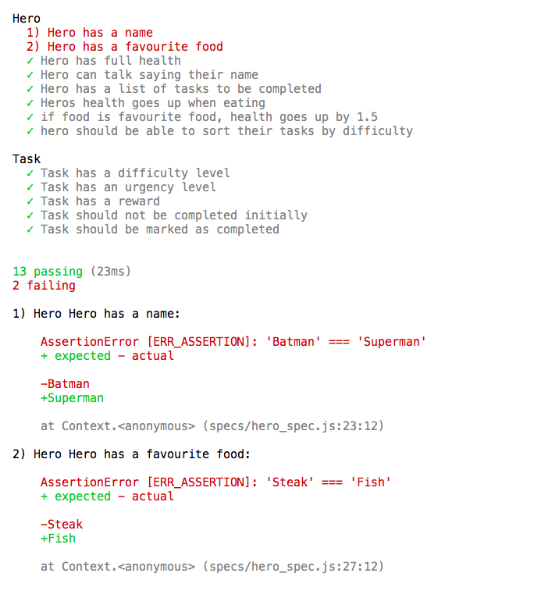

Test code with errors fixed

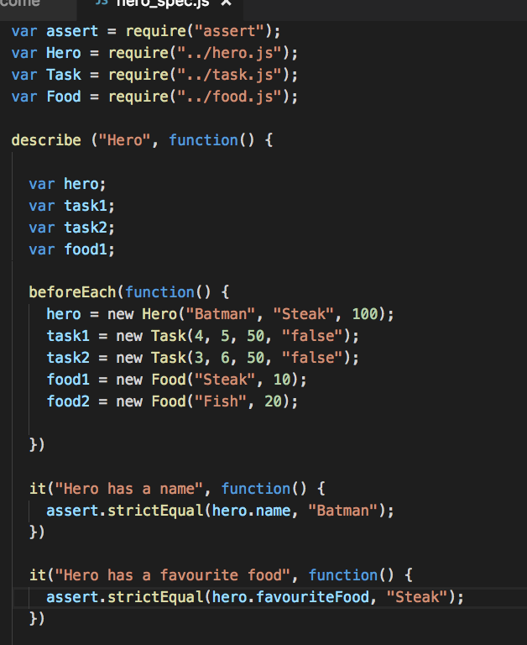

Passing test results now fixed

